**Topology for always on:**

Before implementing your AlwaysOn Availability Group,

There are several prerequisites that need to be done to ensure a successful deployment.

These prerequisites focus on

-> Windows environment.

-> SQL instances.

-> the databases to be included in your AlwaysOn group.

Prerequisites on Windows:

1.Windows Server 2008 Service Pack 2 (SP2) or Windows Server 2008 R2 hotfixes might be applicable for supporting AlwaysOn Availability Groups.

2. Ensure that each computer is a node used for SQL server always on is in a Windows Server Failover Clustering (WSFC) cluster.

3.Ensure that all applicable Window hotfixes have been installed on every node in the WSFC cluster.

Prerequisites on SQl Server:

1. Each server instance must be running the Enterprise Edition of SQL Server 2012 or above.

2. Both the Instances Can belongs to same or can also be In different domain.

3. Cumulative Update 7 for SQL Server 2012 SP1 or later version( recommanded to have SP2).

How many servers and Edition of the windows and SQL required. step by step instructions.

We can go with either one of the setup:

Windows Server Failover Clustering (WSFC) with SQL Server.

or

Failover Clustering and AlwaysOn Availability Groups (SQL Server)

Setup 1:

In Windows Server Failover Clustering (WSFC) with SQL Server,

The Windows level failover cluster will be installed with atleast 2 nodes(OS) which helps in failover(No shared drives)

Install Standalone Installation of SQL Server on it. It needs 2 SQL Server 2012 sp2 Enterprise Editions.

Configure Always on high availability on it.

Windows Server required: atleast 2 Servers.

SQL Server required: 2 SQL Servers.

AlwaysOn Availability: Primary Group on node 1 and secondary replica on node 2.

Step 2:

In Failover Clustering and AlwaysOn Availability Groups (SQL Server).

Here Node 1 and node 2 will be in failover cluster which helps in auto failover for only Primary SQL server Instance.

Another Node 3 will be in same domain but not in failover cluster will be installed Standalone SQL Server.

Windows Server required: alteast 3 Servers.

SQL Server required: 3 SQL Servers.

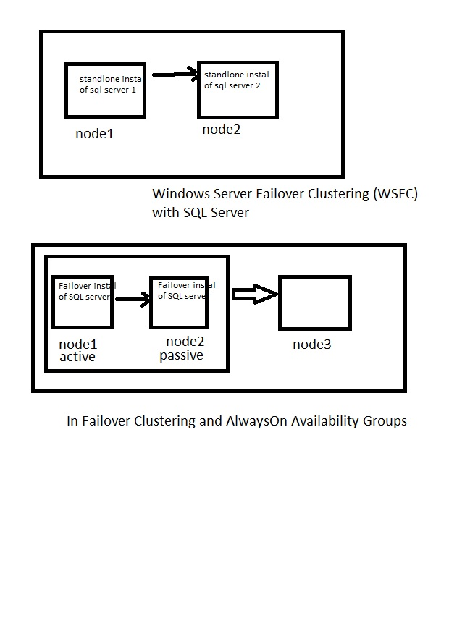

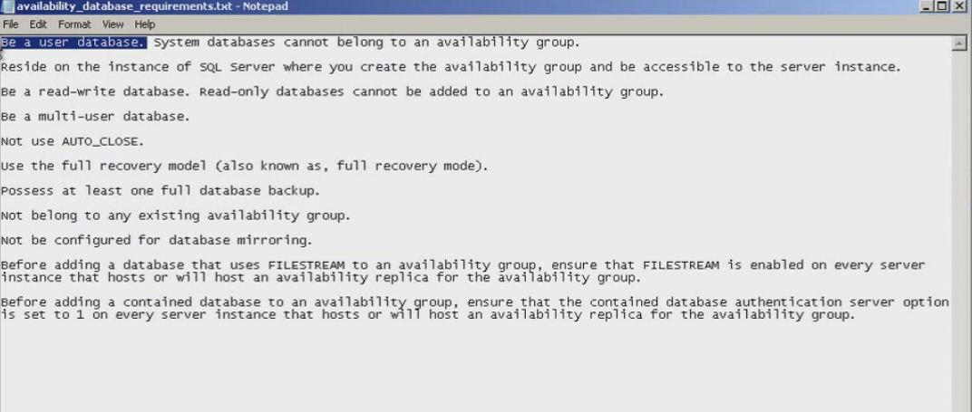

**To setup Always on. Please follow this procedure:**

1. **Environment requirement**
2. **Sql Related requirement**
3. **Listen IP configuration**
4. **Permissions.**

**Sites:** [**https://docs.microsoft.com/en-us/sql/database-engine/availability-groups/windows/overview-of-always-on-availability-groups-sql-server**](https://docs.microsoft.com/en-us/sql/database-engine/availability-groups/windows/overview-of-always-on-availability-groups-sql-server)

[**https://docs.microsoft.com/en-us/sql/database-engine/availability-groups/windows/active-secondaries-readable-secondary-replicas-always-on-availability-groups**](https://docs.microsoft.com/en-us/sql/database-engine/availability-groups/windows/active-secondaries-readable-secondary-replicas-always-on-availability-groups)

**Environment :**

**It is already discussed. Please go through the topology notes.**

**Sql requirement:**

* **SQL Versions dumps sql 2012 SP2 or above. Only Enterprise Edition.**
* **Dot net framework 3.5 sp1 should be installed.**
* **Procure the Disks on all the nodes in the ENV with Same Drive Names and Disk sizes.**
* **Service Accounts to be created.**
* **Enable “Always on” in the configuration manager.**

**Listen IP Configuration:**

* **If the both the nodes are in same network, then One Listener IP is enough. Creation of 2nd Listener is optional.**
* **If the both the nodes are in Different network, then We need to create Individual IP on their own Network. Here if 2 different Networks, we need two Listener IP to communicate.**
* **Also we should specify the DNS name to be created in DNS server for the Listener.**
* **Port no should be provided while configuring the Listener.**
* **Listener configuration is optional.**
* **Listener is used by applications to have a high availability if the primary gets fail overed onto**

**The secondary.**

**Permissions While creating Always on:**

* **Should have admin access on the Machine (or) nodes to install the sql server.**
* **To set always on, we require “Create Computer Object” Read /Write permissions because in cluster install (or) In always on Listener config we are Creating DNS name and assigning their IP address.**

**procedure instructions:**

* Always on is a combination of Both Mirror and Cluster.
* First we need to Create “Always on” Group. Same group should be on other Nodes as well.
* Make sure to add the User Databases in that Group.
* We can configure the DB in Sync mode (or) Async Mode.
* Also we can have multiple Secondary replicas.
* In sql 2012, we can have max up to 4 Replicas including Primary replica.
* 2012 Limits: 1 primary replica, 3 secondary replicas, 2 of the replicas can be synchronous.
* In sql 2014 and 2016, we can have max up to 8 Replicas including Primary replica.
* 2014 Limits: 1 primary replica, 7 secondary replicas, 4 of the replicas can be synchronous.
* 2016 Limits: 1 primary replica, 7 secondary replicas, 4 of the replicas can be synchronous.
* We can also create Multiple AO Groups with Different Listener DNS and IP’s.

Note: Do not use Same Listener IP for multiple AO groups.

* Create the same Folders on all the nodes in the drives.
* Secondary replica will be the standby; no operation can perform in it. We have multiple options to set on Secondary whether to set :
* Readable Secondary=no
* Readable secondary= Yes
* Readable secondary= read Intent only
* If Readable secondary is no, then no one can access the Database. It can just use only if any failover occurs.
* If Readable secondary is Yes, Then the DB can accessible only read action by the users.
* If Readable secondary is “read Intent Only” then no users can be accessible but only the read only application connection string can be connected to the DB for only read purpose.
* If we have requirement to listen on specific node (read only) but not primary. We can specify in the connection string to connect to specific node.
* Application Intent= readonly🡪 It will route to only readable secondaries.
* Application Intent= readwrite 🡪 It will route to only primary replica.
* Application Intent=All 🡪 it can route to any replica.
* Application Intent works in such a way, where no load balance will be supported.
* It will route to the first read intent only replica for the operation, even though we have still one or more read intent replicas.
* Only in case of First Read intent replica is damaged (or) crash (or) inaccessible then the route will be shifted to next listed read intent replica.
* By default Mode is **Async mode**. Here we have possibility of Data loss while failover.
* In Always on the Backup can be trigger on any of the replica (primary or secondary).
* Only Full backup is permitted to trigger on Secondary Replica.
* We can even set the priority to trigger back up on the replicas. Priority by giving in %.
* Endpoints will be used same as mirror (5022 is the default Port)
* Creating of Listener is optional. But it is important for application connection to connect to active replica.
* With the help of Listener If any failover, the control moves to other node where we have an active node. Listener will move the control automatically. So application will not observe any disconnections (or) disturbances.
* To create Listener, we need DNS name of it and respective IP in the network.

Note: If we have multiple networks we need multiple IP’s on their network.

* If listener is not configured, in application config we need to change the connection string that Data source is N1 or N2 whenever failover happens. We need to manually change the connection string.

**Readonly routing List with Example:**

It will identify all the readonly servers only.

It will list all the readonly servers in it.

And operation will send to the first readonly server only and will not send for another readonly.

Ex: If we have 4 server.

1- primary

2- readonly Secondary

3- restoring secondary

4- readonly Secondary

If Application Indent is to connect to Readonly server. We have 2 servers with read only.

Here Readonly routing List will identify both the readonly server.

2- readonly Secondary

4- readonly Secondary

and operation will send to first server in the list(2- readonly Secondary). but not (4- readonly Secondary).

Note: It will not do any load balance. It will send the request to the first identified server.

**Always on Configuration:**

Steps:

1. Check the architecture of the SQL.( Windows Built ENV)

2. If configuring always on, go to primary server and install SQL server 2012 or above

3. In SQl server configure Manager, Enable Always On High availability. And restart the SQL.

4. Go to primary server, create availability group name

5. Select the DB's to be in Availability Group( DB pre-requisites are mentioned above)

6.In this primary, enable if auto failover and sync commit required or not .

We can create the DB's in sync or Async Mode.

Also need to specify when it becomes readable secondary ON, OFF, READ-INTEND ONLY

Off- When auto failover happens, It will become secondary and it will not be readable DB.

ON- When auto failover happens, It will become secondary and it will be readable DB.

Read-Intend Only- When auto failover happens, It will become secondary and it will be readable only for the application connection configured as application intend=readonly. Remaining application connection cannot use this as readable DB.

7. Check the endpoint and its service accounts running

8. Backup preferences( check the preferences in the above)

Note:

We can running only 3 Node(primary and 2 secondary) in Synchronous Mode

We can maintain upto 5 node in Alway on avaiability (1 primary and 4 secondary) in Async Mode.

9. data sync preferences

It will create secondary DB in secondary server.

Full: It will create Full and T-log backup on primary and will copy to the specified location and will try to restore on secondary server.

It may get failed if the drives name, folder name and size are not available on both servers.

Join Only: If the DB's are already restored then it will just join in the availability Group.

Skip: If we have not restored the secondary DB and want to do later time. We can also skip for now and will continue with the Configuration without a DB in it.

10. Validate and create it.

Go to SQl Server 2012 SSMS:

In Availability Group, We can see New Group name (primary) and below Availability replicas means participated Servers.

Availability databases mean the DB's we kept in the Availability group.

While Testing: we can Test by adding data in N1 and can see wheather data reflecting on N2 or N3.

We can suspend the data sync and can resume it.

Via Dashboard we can see the monitoring the Always on group and also we can add columns in dash board.

Note: In Async Mode, After a failover the old secondary will become Primary.

But old primary will not move immediately as secondary . Go to current secondary AO Group and under Availability Databases -> we need to resume the DB’s in the list to make it in Database in Syncing.

Or CMD:

Use Master

go

Alter database <DB name> Set HADR resume